Dear
Membership Grade:
Membership Number:

CRITICAL SKILLS APPLICATION

You have applied for written confirmation regarding your skills / qualification and appropriate post qualification experience in support of a Critical Skills Visa application in terms of Section 19(4) of the Immigrations Act No. 13 of 2002 (as amended).
For the SAIMC to process your application, please forward us the following information:

- Date of birth: ………………….
- The category of the Critical Skill you are applying for: ……………………………..
- Your current responsibilities: …………………………………………………………
- A confirmation letter from your supervisor with his / her contact details confirming your current responsibilities.
- Copies of your qualifications

Your sincerely

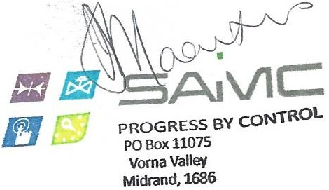

Administrator: SAIMC NPC

